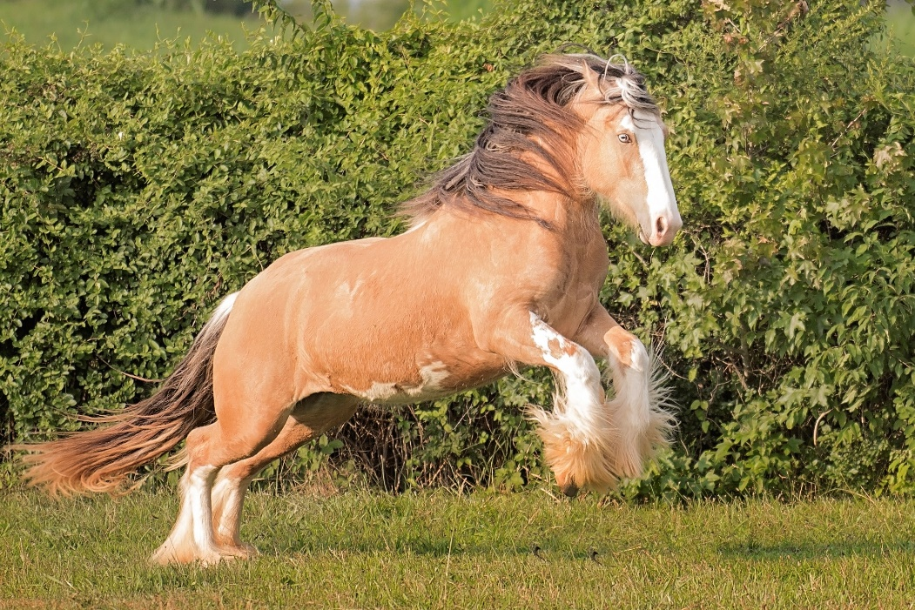
Mane Support’s
Leap of Faith

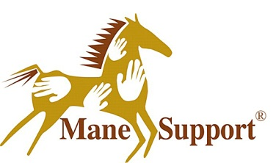
Mane Support is an equine assisted grief counseling program, that provides a ministry to children, youth and adults who have experienced a death, who are anticipating the death of someone they know or who have experienced other types of trauma related to that loss. Over the past 15 years, it has resided in Blount County as a nonprofit and as the only free- standing Grief Center, as named by the State of Tennessee. Now with a partnership with the University of Tennessee, Mane Support has the opportunity to offer its services to Roane County, in a satellite form, with the main campus remaining in Blount County.
Over the years Mane Support has provided individual and family counseling, Horses Helping Heroes for Military and First Responders, the SOS (Supporting Our Schools, in school grief support program and Leading by the Reins team building for all types of groups. As a nonprofit, Kim Henry Founder and CEO, knows that it takes an army, with all types of gifts and talents. Already she has experienced an out pouring of support from this incredible community, with those like Ellen and Bill Furlong pictured below, Jessica Clark previously with LexLin Ranch, Joan Cleary from Jamestown, Maureen Leavitt, Judy Podpadec,Grande Vista Bay Residents, Tammy Poland, Frankie Smith and many more.
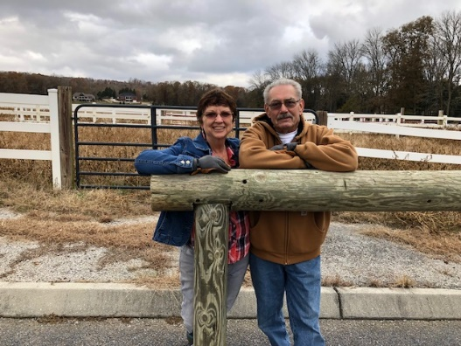
Throughout the past nine years, Kim has taught equine assisted grief counseling at Maryville College and Johnson University. As she continues to teach at Maryville College this spring, she looks forward to partnering with not only colleges and universities but all schools and businesses in this area. She has learned well the meaning of working together and teaching others to carry on the work, so that what God has given one to do, carries on with those whose heart is also lead in that direction.
On Sunday, January 13th from 2:00p.m. until 4:00p.m. Mane Support will host its first Volunteer Training. It will be held as what was previously known as the LexLin Gypsy Vanner Ranch at 1522 New Hope Road in Rockwood. “Even if you just want to come and learn about Mane Support and see the property, please come.” Invites Kim Henry. Volunteer Training gives a good foundation of the ministry and puts people in place to allow it to become a sustainable business for many years to come
Putting this satellite together for this community can be overwhelming, but with the Lord’s guidance and the heart of people, we can all partner together to help those who are hurting in our communities.
At the present, Mane Support is looking for volunteers in all areas of equine, fundraising, grant writing and more, board members who have a heart for this type of work, business minded and connected to family and community and interns in the areas of counseling, equine management and care, agriculture, social work, veterinary medicine, hospice, nursing, and more.
Ideas in the works to help Mane Support’s satellite succeed is Mane Stay, a short term stay horse hotel (see attached flyer), projected spring and summer camps and retreats….all supporting the needs of those who are hurting and who are working with those children and adults who are grieving. The first workshop is scheduled for Saturday, January 19th, CONNECTING HANDS, HEARTS, HORSES, AND HEALING.

Please visit Mane Support’s website at www.manesupport.org for further information or email Kim Henry personally to set up time to meet, register for Volunteer Training, Mane Stay or the January Workshop at kkhenry@manesupport.org.

OPENING JANUARY 7TH 2019
Mane Support’s Mane Stay
Mane Support’s Rockwood location, conveniently situated 8 miles from the Roane State Community College Expo Center, is offering overnight boarding for show enthusiasts, leisurely travelers and transporters.
The facility features:
- A 25 stall barn with 16 stalls reserved for Mane Stay
- Trailer parking
- Hay available on request
- 1-3 night stays
- Wash racks
*No stallion boarding
*Paddock availability dependent upon scheduling and activities
*Must have updated health papers and coggins

We are minutes away from Interstate 40 Exit 350, convenient shopping centers, the expo center, and multiple hotels featuring various amenities.

Mane Support’s Mane Stay
1522 New Hope Rd Rockwood TN 37854
Phone: (865) 414-0557
Email: kkhenry@manesupport.org
Website: www.manesupport.org
Cost: $65.00 per night/per horse. Includes hay, if needed.

Facilities include 16 12x12 Stalls, automatic water, and electric for each stall. Paddock areas are available depending on scheduling and activities. Wash racks available, trailer space available as space allows, and hay available on request. Five minutes from Expo center, shopping and hotel stays. Available for 1-3 night boarding.

All proceeds from Mane Stay go to support the programs of the nonprofit Mane Support and are tax-deductible
Reservations are appreciated, but not necessary
(865)414-0557

Mane Support is an equine assisted grief counseling program, that provides a ministry to children, youth and adults who have experienced a death, who are anticipating the death of someone they know or who have experienced other types of trauma related to that loss. Over the past 15 years, it has continued by those who are committed to using their gifts, talents and resources.
Below are opportunities in which YOU can be a part of Mane Support!
It’s easy!
- Check the box or boxes beside your area of giving.
- Fill out the information on the back.
- Return it to a Mane Support representative or to the Mane Support Office.
Thank you in advance, for your investment in the life of a child, family, veteran, horse or community. Because of you, Mane Support continues to grow to be what it needs to be, to help those in need and educate those who will carry on its mission for many more years to come.
Levels of Investment

Friend of Mane Support 50.00 per month for 1 year
Name a Brick in Honor or in Memory 100.00 per brick
Adopt a Horse 300.00 one-time amount
Horse Sponsorship 100.00 per month for 1 year
Stall Sponsor 500.00 per year
Foundation Support 1000.00 per year
Rafter Support 5000.00 per year
Volunteer
Board Member
Personal Information

Name: _____________________________________________________

Email:______________________________________________________

Address:____________________________________________________

Phone:_____________________________________________________

Qualified Charitable Distribution (QCD) _________________________

Method of Payment:__________________________________________

Mailing Address, if you are sending a check: Mane Support 2919 Davis Ford Road Maryville, TN 37804

Thank you for all of your generosity as we all work together to help those who are hurting in our communities!

